A Level D&T: Product Design
Transition Pack

A guide to help you get ready for A Level D&T: Product Design

You will be studying A Level D&T: Product Design. Textbooks will be available to loan in exchange for a deposit in September. It is recommended that you provide your own A4 Lever arch folder for notes.

This Transition Pack contains a programme of activities and resources to help you prepare for the start of your studies in September 2020. Over the next two years your Product Design course will cover:
Year 12
Preparation for Paper 1 Technical Principles
120 marks (30% of entire A Level), mixture of short and extended response questions.
Preparation for Paper 2 Designing & Making Principles
Section A: Product Analysis (30 marks)
Section B: Commercial Manufacture (50 marks)
Total 80 marks (20% of entire A Level)

NEA (Non-examined Assessment (starting in January 2021)
Substantial design and make project, assessing the practical application of technical principles, designing and making principles. 100 marks (50% of the entire A Level).

Year 13
Paper 1 Technical Principles
Paper 2 Designing & Making Principles

NEA (Non-examined Assessment (deadline March 2022)

You should aim to spend some time over the summer holidays doing some of the things identified in this pack.

If you would like to contact us by e-mail, our e-mail addresses are as follows:
Mr Burt: burt@cambornescience.co.uk
Mrs McIntosh: mcintoshl@cambornescience.co.uk

Section 1: Revisiting GCSE
You will be provided with an electronic copy of the PG Online GCSE D&T text book. Use this to answer the questions which relate to the content of the text book. Below is an overview of the GCSE specification as a reminder of the work you covered on your GCSE D&T course.
Section 1 New and emerging technologies
- Industry and Enterprise
- Sustainability and the environment
- People, culture and society
- Production techniques and systems
- Informing design decisions
Section 2 Energy, materials, systems and devices
- Energy generation
- Energy storage
- Modern materials
- Smart materials
- Composite materials and technical textiles
- Systems approach to designing
- Electronic systems processing
- Mechanical devices
Section 3 Materials and their working properties
- Papers and boards
- Natural and manufactured timbers
- Metals and alloys
- Polymers
- Textiles
Section 4 Common specialist technical principles
- Forces and stresses on materials and objects
- Improving functionality
- Ecological and social footprint
- The six Rs
- Scales of production
Section 5b Timber based materials
- Sources, origins and properties
- Working with timber based materials
- Commercial manufacturing, surface treatments and finishes
Section 6 Designing principles
- Investigation, primary and secondary data
- The work of others
- Design strategies
- Communication of design ideas and prototype development
Section 7 Making principles
- Selection of materials and components
- Tolerances and allowances
- Material management and marking out
- Specialist tools, equipment, techniques and processes
- Surface treatments and finishes

Section 1 New and emerging technologies
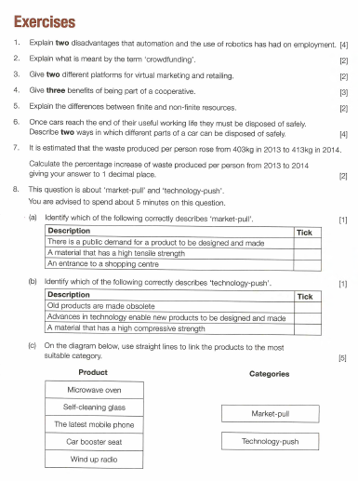

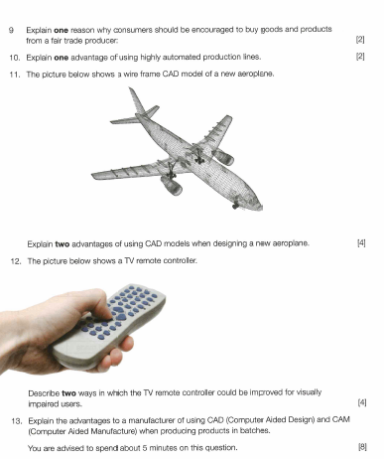

Section 2 Energy, materials, systems and devices
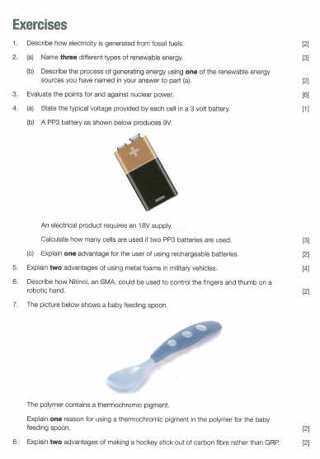
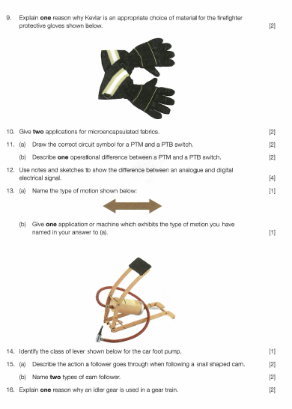

Section 3 Materials and their working properties
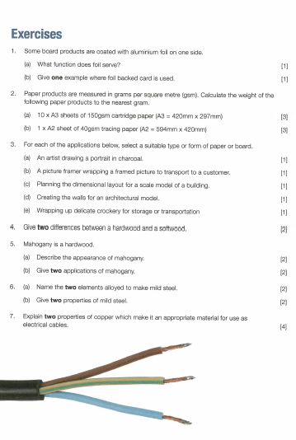
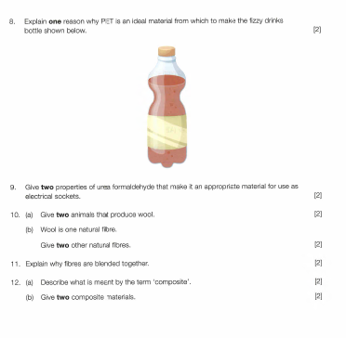

Section 4 Common specialist technical principles
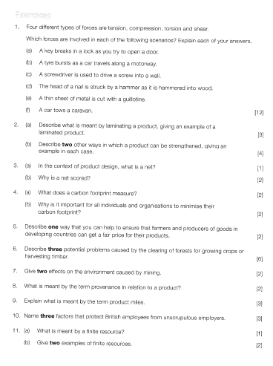
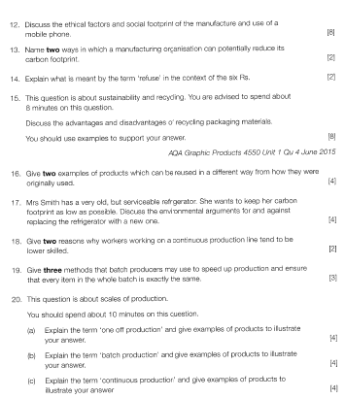

Section 5b Timber based materials
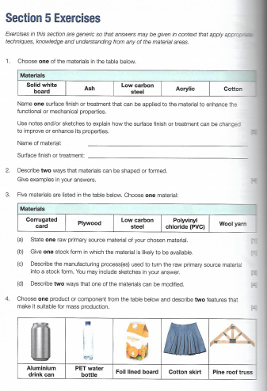
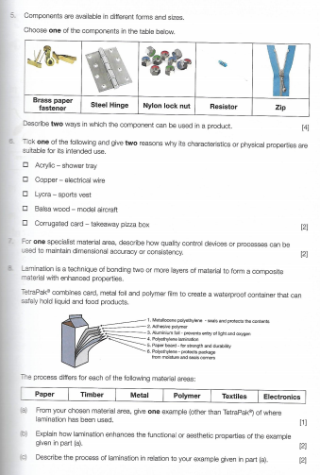

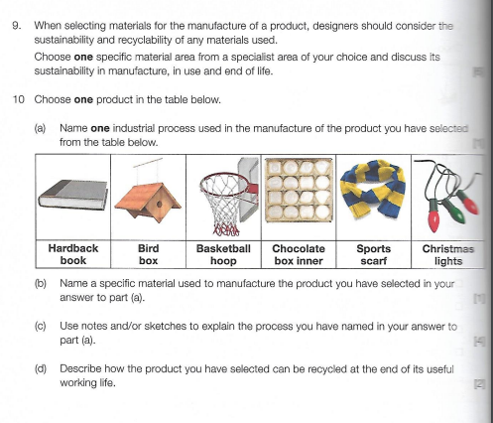

Section 6 Designing principles
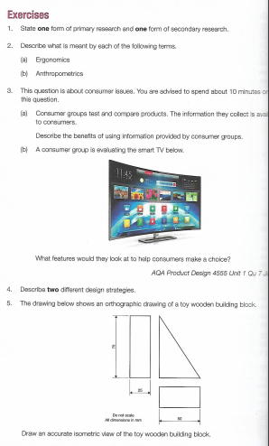

Section 7 Making principles
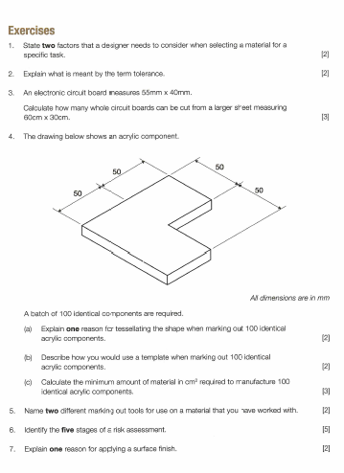

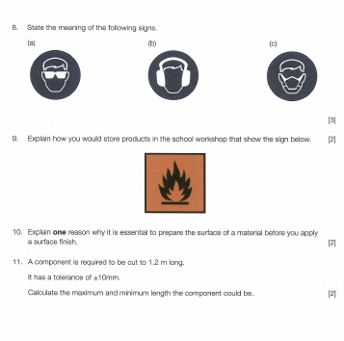

Section 2: Transition to A level
Paper 1 and 2 - Subject Content
Use your existing knowledge and/or the electronic scans of the GCSE text book to complete a short summary of each of the topics in Chapters 1 and 2 of the A Level Product Design text book.
https://m.youtube.com/watch?feature=youtu.be&v=d-L7xOmioIY&d=n This YouTube clip will help you get started.

Topic | Short Summary
Plastics

Elastomers

Composite Materials

Ferrous Metals

Topic | Short Summary
Non-ferrous metals

Alloys and alloying

Wood

Veneers, laminates and composites

Glass

Topic | Short Summary
Ceramics
Paper & Board
Printing
Smart and modern materials

Topic | Short Summary
Joining processes
Joining metals
Joining wood
Joining polymers
Joining ceramics
Corrosion, decay and degradation

Topic | Short Summary
Finishes and finishing processes

Properties and materials testing

Environmental and sustainability issues

Ergonomics and anthropometrics

Inclusive design

Consumer safety

Section 3: Extension and Challenge
If you are aiming for an A / A* at A level then you should aim to complete some of these tasks. Choose the ones which interest you most.
The James Dyson Foundation are very supportive and encouraging of design and engineering education.
Have a look at their website and the design competition in particular, that they run for undergraduate and graduate students.
https://www.jamesdysonaward.org/home/
https://www.jamesdysonaward.org/past-winners/
Although you are not eligible to enter we would like to see your response to the brief below.
“The brief is broad. We’re looking for designers who think differently, to create products that work better.
Designers and engineers who follow an iterative design process. The judges – and James Dyson especially – are drawn to designs that employ clever yet simple engineering principles and address clear problems.
As well as proving your project’s technical viability, we'd also love to see that it’s commercially viable, too – so include any research you've done into manufacturing costs and retail prices.
This year the James Dyson will also looking for entries that address a sustainability issue, or have been designed, sourced or manufactured sustainably.”
There are also a number of design and science challenges on a set of cards. Some may be too simple but consider having a try of the engineering challenges numbers 5, 8, 13 and 14.
https://www.jamesdysonfoundation.co.uk/content/dam/pdf/JDF_with%20cover%20challenge-cards_DIGITAL.pdf?
FixEd and Fixperts is also an interesting organisation
http://fixing.education/ Please have a look at their website, especially Fixperts.
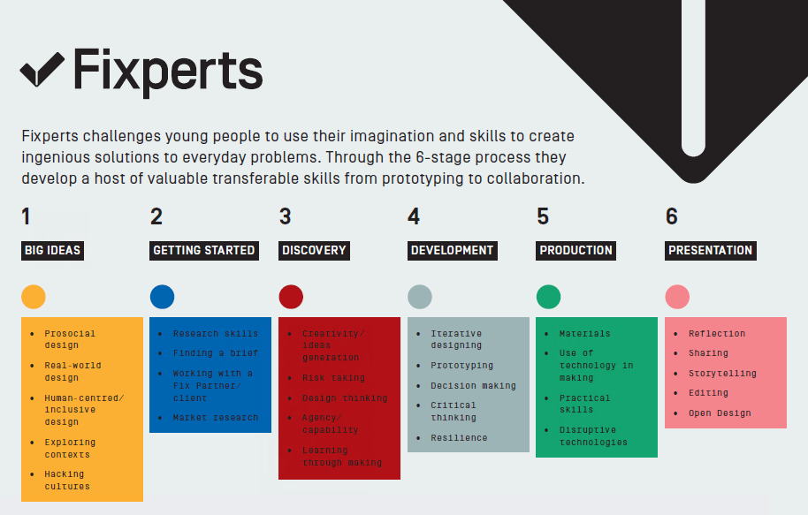
Or some of their films on YouTube
https://www.youtube.com/channel/UCVYwsZAvnI8snvJ6aufbvCg

A link to a useful reading list is below.
https://www.innovationtraining.org/design-thinking-books-to-read/
https://www.futurelearn.com/courses
Section 4: Go Beyond the Spec
Develop and demonstrate your interest in your chosen subject by extending your subject knowledge beyond the specification – it can include on-line reading / movies etc.
Watch these lockdown lectures from Jude Pullen a lecturer at Bangor University. Please write a short review of them. There will be more to follow …
https://www.youtube.com/watch?v=r5J65bZRseA
https://www.youtube.com/watch?v=c_5vQex8two
https://www.youtube.com/watch?v=jcFFZWQjuOM
https://www.youtube.com/watch?v=lYpfTIQdgVU

Modelling and prototyping
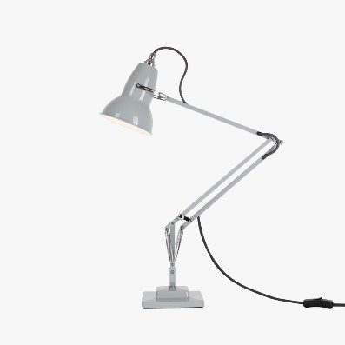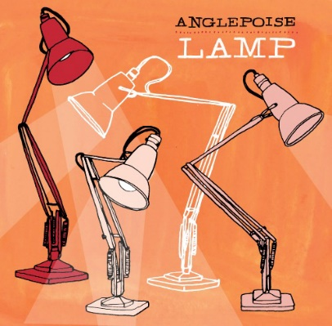

The Anglepoise lamp is a design classic. We would also like you to complete this task. If you cannot access the materials or tools be creative and model your lamp using the step by step guide. Photograph each stage and annotate it like you would a plan or diary of making. Then evaluate your final prototype.
https://www.theguardian.com/lifeandstyle/house-and-homes-blog/2011/oct/05/how-to-make-anglepoise-jar-lamp
Designers and their work.
Have a look at some of the profiles and work of well-known and esteemed designers who have shaped the way we live today. Please pick at least one and produce an A3 piece of work about them. We are looking for creativity in presentation, a range of images both hand drawn and internet generated, your reaction to the work. Please do not just cut and paste !
https://designmuseum.org/designers

BBC Programmes
There is a great range of programmes about design and manufacture on BBC iplayer. Please try to watch some of the clips or programmes below and write about your views, what you have learnt etc in the appropriate table below.
https://www.bbc.co.uk/programmes/b006m9ry/episodes/player
https://www.bbc.co.uk/iplayer/episode/m000h3cs/how-to-make-series-1-2-the-toothbrush
https://www.bbc.co.uk/iplayer/episode/m000hbdk/how-to-make-series-1-3-headphones
Drawing skills and scrap book
Please start collecting images of examples of good design either by photographing and/or sketching them. Also include examples of design that you feel could be improved upon or re thought or hacked, explain your changes.

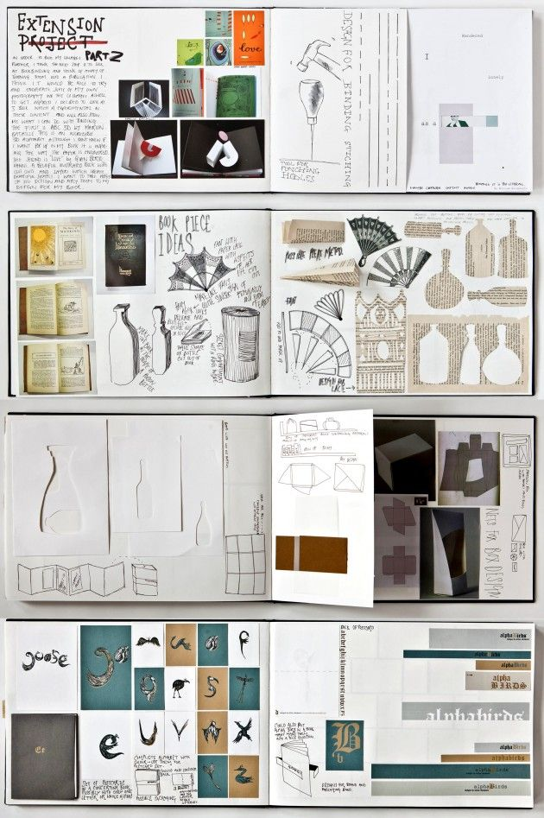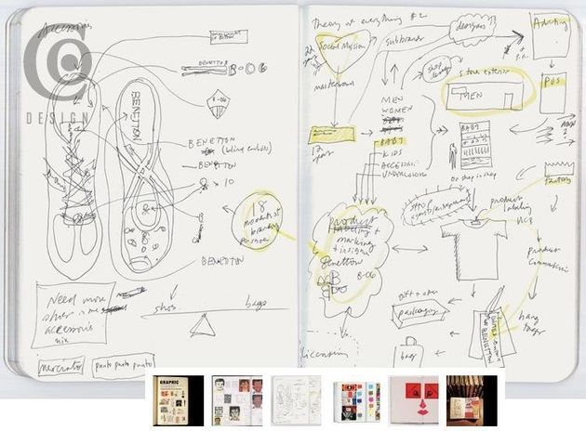

Reading List
Author | Title | Comments
Will Potts, Julia Morrison, Ian Granger, Dave Sumpner | AQA A Level Product Design
Simon Alderson and Ralph Ball | Mass Production: Products from Phaidon Design Classics
Marcus Fairs | 21st Century Design
Tubal Cain | Hardening, Tempering and Heat Treatment
Design Museum Enterprise Limited | Fifty Cars that Changed the World: Design Museum Fifty
Ed Mae Cooper | Starck
Rob Thompson | Manufacturing Processes for Design Professionals

Website | Comments
www.designmuseum.org
www.apple.com/uk
www.jamesdysonfoundation.co.uk
www.starck.com
www.theartstory.org
www.ted.com/playlists/28/sustainability_by_design
www. http://cfsd.org.uk/
www.hse.gov.uk

Any time you do anything that has any links to Product Design take a note. There is an example in the first row.

Date | Activity | I learnt…
14/6/18 | BBC I-Player, Building Cars Live | I learnt about production lines, quality control, quality assurance and just in time manufacture

